Radiomics-Based Machine Learning and Deep Learning for Clinically Significant Prostate Cancer Detection on Biparametric MRI
Jesus Alejandro Alzate-Grisales
Mario Alejandro Bravo-Ortiz
Luis Miguel Cardona Pérez
Salomé López Marulanda
Miguel Perán-Teruel
Azahar Navarro Beltrán
Clara Ruiz Torres
José Manuel Osca García
Francisco García-García
Reinel Tabares-Soto
Juan M García-Gómez
Maria de la Iglesia-Vayá
Abstract
We benchmarked radiomics-based classical machine learning against deep tabular learning for case-level detection of clinically significant prostate cancer (csPCa) on biparametric MRI, and assessed the added value of routine clinical variables. The full PI-CAI Public Training and Development Dataset (1,500 studies, 1,476 patients, 425 csPCa-positive, 28.3% prevalence) was analyzed under the official patient-grouped five-fold cross-validation. Whole-gland radiomic features from T2-weighted, apparent diffusion coefficient, and high b-value diffusion-weighted imaging were used to train three classical models (Random Forest, Gradient Boosting, LightGBM) and three deep models (tabular Transformer, CapsNet, Transformer–CapsNet hybrid) on a shared, leakage-safe, fold-specific feature-selection plan with calibration and an outer-training-derived threshold. Age, prostate-specific antigen (PSA), PSA density, and prostate volume were evaluated alone, by concatenation, and by dual-branch fusion. Metrics were computed on aligned out-of-fold predictions with patient-level cluster-bootstrap 95% confidence intervals. The Random Forest gave the best radiomics-only discrimination (AUROC 0.814, 95% CI 0.790–0.837; AUPRC 0.605), but its advantage over the Transformer was not significant after multiplicity adjustment ($Δ$AUROC 0.014; Holm-adjusted $P=0.204$). Radiomics clearly outperformed clinical variables alone (AUROC 0.754); adding clinical variables by concatenation produced a modest gain (AUROC 0.828; Holm-adjusted $P<0.001$), with no benefit from dual-branch fusion over concatenation ($P=0.736$). Center-stratified analysis revealed marked heterogeneity, with significantly lower discrimination at one of three centers (AUROC 0.74 vs. 0.84 elsewhere). A calibrated classical ensemble thus matched deep pipelines on this engineered feature space and clinical variables added modest value, but aggregate performance masked clinically relevant between-center variation. These comparisons are exploratory, as model families were screened on the same cohort.

Introduction
Prostate cancer (PCa) is one of the most frequently diagnosed malignancies in men and remains a leading cause of cancer-related mortality, making accurate detection and risk stratification essential for guiding management . Multiparametric magnetic resonance imaging (mpMRI) has become a key tool for the non-invasive evaluation of suspected PCa and is now recommended before biopsy in many diagnostic pathways. To this end, the Prostate Imaging Reporting and Data System (PI-RADS) provides a standardized framework for image acquisition, interpretation, and reporting . However, PI-RADS assessments remain subject to inter-reader variability and may lead both to missed clinically significant disease and to unnecessary biopsies in men with equivocal lesions .
Radiomics has emerged as a promising approach to address these limitations by extracting large numbers of quantitative features from medical images and using them as objective imaging biomarkers for tumor detection, grading, and prognosis . Recent narrative and systematic reviews of MRI-derived radiomics models for PCa highlight applications in lesion detection, Gleason score prediction, and outcome estimation. These reviews report that well-constructed models often achieve areas under the receiver operating characteristic curve (AUROC) in the range of approximately 0.80 to 0.90 during internal validation; however, they also underscore substantial methodological heterogeneity, emphasizing the need for standardized pipelines and transparent reporting .
Radiomics-based machine-learning (ML) models have been developed on both mpMRI and biparametric MRI (bpMRI), typically utilizing T2-weighted and diffusion-weighted or apparent diffusion coefficient (ADC) sequences, with lesion- or gland-level segmentations serving as regions of interest . In heterogeneous multicenter datasets, tree-based classifiers—such as Random Forests—trained on engineered shape, intensity, and texture features have achieved AUROCs of 0.78 to 0.83 for clinically significant PCa (csPCa). When appropriate bias-mitigation and cross-validation strategies are applied, these models perform comparably to conventional imaging biomarkers such as mean ADC, PI-RADS, and prostate-specific antigen (PSA) density . More recently, a multicenter retrospective study in real-world clinical practice evaluating 1,616 patients across four tertiary centers demonstrated that Random Forest-based models reached AUROCs of 0.874 to 0.893 across internal and external test cohorts, and that radiomics-adjusted PI-RADS scores improved specificity with only a slight sacrifice to sensitivity .
The relative performance of classical radiomics-based ML versus deep learning (DL) remains an active topic of investigation. A validation study by Castillo et al. compared a radiomics model based on delineated mpMRI regions with a fully automated DL model for csPCa classification across three independent test cohorts. While DL obtained a higher AUROC during internal cross-validation, the classical radiomics model achieved a higher AUROC on all external cohorts, suggesting better generalizability of the radiomics approach under those conditions . Systematic reviews of bpMRI further support that while both paradigms can reach AUCs in the mid-0.80 range, DL often requires substantially larger training cohorts and may be particularly sensitive to domain shift, whereas tree-based ensembles remain highly competitive on tabular radiomic feature spaces .
An important line of research has focused on combining these radiomics profiles with routine clinical variables to build multimodal risk models. In a large single-center retrospective study (1,497 MRI exams from 1,395 men), Antolín et al. developed four Random Forest-based models using automatically segmented whole-gland radiomics, PI-RADS, and clinical variables . In their validation cohort, radiomics alone did not significantly outperform PI-RADS (AUC 0.838 vs. 0.833), but the combined clinical-radiomics-PI-RADS model achieved an AUC of 0.891, significantly outperforming the simpler models and providing the optimal trade-off between sensitivity, specificity, and biopsy avoidance . Other clinical-radiomics models targeting PI-RADS 3 lesions or transition-zone tumors likewise confirm that adding radiomics to routine predictors—such as age, PSA, PSA density, and prostate volume—can yield modest but clinically meaningful gains in discrimination and decision-curve net benefit .
Against this background, large multicenter datasets and standardized evaluation protocols have been introduced to benchmark AI models for csPCa detection. Recent multicenter studies have evaluated MRI-based models designed to mimic routine practice, demonstrating that calibrated radiomics models can lower the proportion of equivocal cases while maintaining high negative predictive values . Concurrently, methodological reviews and the TRIPOD+AI statement call for more rigorous evaluation protocols, including patient-grouped cross-validation, strictly isolated feature-selection strategies, probability calibration, decision-curve analysis, and formal statistical comparison of competing models .
The present study addresses several of these methodological gaps by benchmarking classical ML and deep tabular learning on an identical, IBSI-compliant whole-gland radiomic feature space derived from bpMRI. This evaluation utilizes the large, multicenter Prostate Imaging: Cancer AI (PI-CAI) public training and development dataset (1,500 studies from 1,476 patients, csPCa prevalence 28.3 %). Radiomic features are extracted from T2-weighted imaging, ADC maps, and high-$b$-value diffusion-weighted imaging using a unified pipeline. Performance is evaluated via patient-grouped five-fold cross-validation, employing strictly in-fold feature selection, probability calibration, and aligned out-of-fold predictions shared across all models. Furthermore, this study quantifies the incremental value of four routinely available clinical variables (age, PSA, PSA density, and prostate volume) and compares simple feature concatenation against a more complex dual-branch deep-fusion strategy. Supported by comprehensive interpretability analyses—including feature-selection stability, cross-model feature importance, and spatial back-projection of radiomic descriptors—the primary objective is to determine whether deep tabular models confer a genuine discrimination advantage over strong tree-ensemble baselines, and to assess exactly how much routinely collected clinical information adds to a calibrated, radiomics-based csPCa risk model.

Materials and Methods
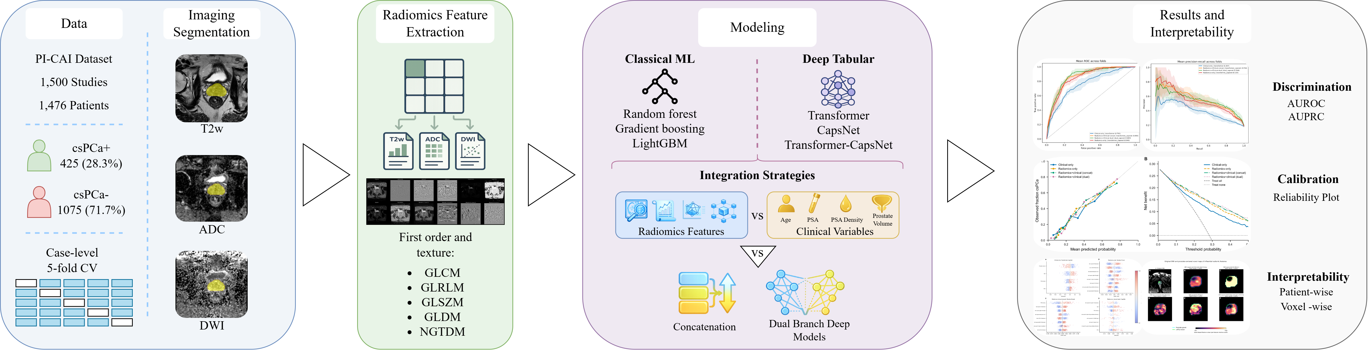
Overview of the study pipeline. Biparametric MRI studies (T2-weighted, ADC, high b-value DWI) and whole-gland segmentation masks are processed through modality-specific extraction pipelines to build a multimodal radiomic feature table. A predefined patient-grouped five-fold cross-validation split is shared by all experimental conditions.
This study benchmarked classical machine learning (ML) against deep tabular learning (DL) for binary classification of clinically significant prostate cancer (csPCa) on biparametric MRI, and quantified the value added by routine clinical variables. Four conditions were evaluated (Figure 1): radiomics-only, clinical-only, and two strategies that combine both sources (feature concatenation and dual-branch deep fusion). All conditions reused a single predefined cross-validation partition and, where radiomic features were included, a locked fold-specific feature-selection plan, so that performance differences reflected only the added information and the fusion strategy rather than the evaluation protocol. Reporting follows the TRIPOD+AI statement and the radiomics quality recommendations of .

Study cohort and outcome definition
Biparametric MRI studies were drawn from the Prostate Imaging: Cancer AI (PI-CAI) dataset , a large multicenter collection of prostate MRI studies with histopathological outcomes and expert-derived annotations. The outcome was clinically significant prostate cancer, defined by the histopathological threshold of International Society of Urological Pathology (ISUP) grade group $≥2$ : grade groups 0–1 were labeled non-csPCa and grade groups $≥2$ csPCa. The cohort comprised the full PI-CAI Public Training and Development Dataset (1,500 studies from 1,476 patients), of which 425 (28.3%) were csPCa-positive (Table 1). The five outer cross-validation folds were taken directly from the official PI-CAI case-level partition, which groups studies at the patient level so that all studies from a given patient fall in a single fold; the small excess of studies over patients reflects patients with more than one study. These folds were not constructed to hold out acquisition centers, scanner vendors, or imaging protocols. The contributing center and scanner model were recovered for all 1,500 studies from the imaging provenance metadata, identifying three centers—Radboud University Medical Center (RUMC, Nijmegen; $n=800$), Prostaat Centrum Noord-Nederland (PCNN, Groningen; $n=350$), and Ziekenhuisgroep Twente (ZGT, Hengelo; $n=350$)—and seven distinct scanner models; PI-RADS scores were not recoverable at the case or lesion level from the public metadata, marksheets, or delineation files. The cohort was heterogeneous across centers: csPCa prevalence (31.1%, 29.5%, and 22.9% for PCNN, RUMC, and ZGT; $χ^{2}$ $P=0.029$), patient age, serum PSA, and prostate volume all differed significantly between centers (Kruskal–Wallis $P<{10}^{-5}$), whereas PSA density did not ($P=0.48$). Because the official folds group patients but are not center-disjoint, this allowed per-center reporting of discrimination (Section 3.3) but not leave-one-center-out retraining; the evaluation should therefore be interpreted as multicenter internal validation with center-stratified subgroup performance, rather than as evidence of transportability to an unseen center. Radiomic features were extracted throughout from a single, uniform automated whole-gland segmentation (Bosma22b) for every study, so that the lesion-delineation provenance present in the dataset did not enter the radiomic feature space.
Cohort characteristics. csPCa is defined as ISUP grade group $≥2$. Continuous variables are median (interquartile range), compared with the Mann–Whitney U test.
Variable | Overall | Non-csPCa | csPCa | Missing, n | $$P$$
Cases, n | 1500 | 1075 | 425 | 0
Patients, n | 1476 | 1057 | 425 | 0
Age, years | 66 (61–70) | 65 (60–69) | 68 (64–73) | 0 | $$<0.001$$
PSA, ng/mL | 8.5 (5.9–13.0) | 7.8 (5.4–11.8) | 10.0 (6.8–17.0) | 40 | $$<0.001$$
PSA density, ng/mL/cm$​^{3}$ | 0.14 (0.09–0.22) | 0.12 (0.08–0.18) | 0.21 (0.13–0.36) | 451 | $$<0.001$$
Prostate volume, cm$​^{3}$ | 57 (40–80) | 61 (43–87) | 48 (35–64) | 27 | $$<0.001$$
ISUP grade group 0, n (%) | 847 (56.5) | 847 | 0 | 0
ISUP grade group 1, n (%) | 228 (15.2) | 228 | 0 | 0
ISUP grade group 2, n (%) | 234 (15.6) | 0 | 234 | 0
ISUP grade group 3, n (%) | 99 (6.6) | 0 | 99 | 0
ISUP grade group 4, n (%) | 40 (2.7) | 0 | 40 | 0
ISUP grade group 5, n (%) | 52 (3.5) | 0 | 52 | 0

Image acquisition and radiomic feature extraction
Three image series were used: T2-weighted imaging (T2w), the apparent diffusion coefficient (ADC) map derived from multi-b-value diffusion-weighted MRI, and high b-value diffusion-weighted imaging (DWI). T2w provides high-resolution zonal anatomy and is the primary sequence for lesion localization under PI-RADS v2.1 ; the ADC map is a quantitative measure of tissue diffusivity, reduced in hypercellular tumors; and high b-value DWI is sensitive to the restricted diffusion characteristic of csPCa. Radiomic features were computed at the study level from the whole-gland region of interest, using whole-gland masks provided with the dataset, framing the task as study-level binary classification.
Features were extracted with PyRadiomics v3 following the Image Biomarker Standardization Initiative . Extraction settings were tailored per sequence (Table [tab:extraction]) but used an identical set of image filters and texture feature families across sequences, so that each modality contributed comparable descriptors; ADC normalization was disabled to preserve the quantitative interpretation of diffusion coefficients. Modality-specific tables were merged into a single multimodal feature table on a common study identifier; when clinical variables were included, age, prostate-specific antigen (PSA), PSA density, and prostate volume were appended to this table.
lccc Setting & T2w & ADC & DWI
Intensity normalization & Yes (scale 100) & No & Yes (scale 100)
Post-normalization shift & $+300$ & — & $+300$
In-plane resampling (B-spline) & 0.42 mm & 1.85 mm & 1.85 mm
Forced 2D (axial) extraction & Yes & Yes & Yes
Discretization bin width & 11.93 & 61.27 & 37.05

Feature selection and cross-validation
Performance was estimated with the official PI-CAI patient-grouped five-fold cross-validation, shared across every condition and across the ML and DL pipelines. For each fold, all preprocessing, feature selection, hyperparameter optimization, probability calibration, and (for deep models) early-stopping decisions were performed using the training partition only, and performance was evaluated on the held-out validation partition, which was never observed during fitting or model selection. Out-of-fold predictions were accumulated across all five folds to form a complete set of study-level calibrated probabilities for aggregate analysis.
Feature selection was performed independently within each training fold to prevent leakage. Each candidate feature was tested for association with the csPCa label using a distribution-appropriate univariate test (Welch’s $t$-test for approximately normal features, otherwise the Mann–Whitney U test ), with Benjamini–Hochberg false-discovery-rate control at $α=0.05$ . Surviving features were pruned for redundancy by removing, within each pair exceeding a Pearson correlation of $0.95$, the feature with the lower univariate discrimination, and the remaining features were capped at a data-adaptive limit derived from the fold sample size and minority-class count (minimum 30, maximum 100 features). The resulting fold-specific feature set was shared identically by the classical and deep models, so observed differences were not attributable to different feature subsets. Clinical variables, when present, bypassed this filter and were retained unconditionally, preserving their interpretability as established urological signals. Missing PSA density was first completed deterministically as the ratio of PSA to prostate volume whenever both source values were available; any remaining missing clinical values were then imputed by the training-fold median, and all clinical variables were standardized using training-fold statistics, with both the derivation and the imputation/scaling statistics transferred unchanged to the validation fold.

Predictive models
Three classical ensemble algorithms served as the radiomics-only ML baselines: Random Forest , Gradient Boosting , and LightGBM . These were chosen from a preliminary screening of twelve classifiers (including support vector machines, regularized logistic regression, discriminant analysis, $k$-nearest neighbors, naive Bayes, decision tree, AdaBoost, and Extra Trees) evaluated by repeated patient-grouped cross-validation (five folds, ten repetitions); the three highest-ranked models by pooled out-of-fold AUROC were promoted to the final benchmark. This screening used the same 1,500-study cohort as the final five-fold evaluation rather than an independent development sample. Consequently, comparisons involving the retained algorithms or data-selected condition winners are treated as exploratory, and their confidence intervals are conditional on the selected model set. For each fold, hyperparameters were tuned by randomized search with inner cross-validation, class imbalance was addressed by inverse-frequency weighting, and predicted probabilities were calibrated by Platt scaling fit on held-out training-fold predictions.
The deep architectures were chosen to probe two distinct and complementary inductive biases for tabular data while keeping a controlled comparison against the classical ensembles. Radiomic feature vectors are moderate-dimensional, strongly inter-correlated, and informative chiefly through higher-order interactions among intensity, texture, and shape descriptors; a plain multilayer perceptron captures such interactions only implicitly and tends to overfit at the present sample size. We therefore selected, first, a tabular Transformer, whose self-attention reweights each feature in the context of all others and thereby models feature–feature interactions explicitly; attention-based models are the strongest contemporary deep competitors to gradient-boosted trees on tabular benchmarks and are thus the natural deep counterpart to the classical baselines. Second, a Capsule Network, which replaces scalar activations with vector-valued capsules refined by dynamic routing ; by encoding part–whole relationships and instantiation parameters rather than mere feature presence, it offers a different representational prior that may group related radiomic descriptors and improve robustness in the low-sample regime typical of radiomics. Third, a Transformer–CapsNet hybrid that composes the two biases—attention-based interaction modeling followed by routing-based agreement—to test whether they are complementary. Together the three span the leading paradigms for deep tabular learning while sharing the feature space and outer folds of the classical models.
These three deep tabular architectures were evaluated on the same selected features. The tabular Transformer maps the input through GELU-activated dense layers with batch normalization into a sequence of learned tokens, applies two multi-head self-attention blocks with a learnable positional embedding, and aggregates the sequence by attention pooling before a sigmoid output; it is trained with focal loss using the Adam optimizer with decoupled weight decay and cosine decay with warm restarts . The CapsNet encodes features into primary capsules and refines two class capsules through dynamic routing, trained with margin loss, and the Transformer–CapsNet hybrid feeds the Transformer token sequence into the capsule routing stage. For each deep model and outer fold, an internal 80:20 split of the outer-training partition was first used for early stopping, Platt scaling, and operating-threshold selection. A freshly initialized model was then trained on the complete outer-training partition for the selected number of epochs. The calibration map and threshold estimated without outer-fold labels were applied to this refitted model’s held-out predictions. Thus, the final classical and deep estimators both used the complete outer-training partition, although their inner hyperparameter- and epoch-selection procedures differed.
Routinely available clinical variables (age, PSA, PSA density, prostate volume) were evaluated in three additional conditions on the same folds and protocols. In the clinical-only condition, models were trained on the four variables alone. In the concatenation condition, the variables were appended to the fold-specific radiomic subset and passed to the same single-stream ML and DL models without architectural change. In the dual-branch condition, clinical and radiomic inputs were processed by two independent branches (no shared weights before fusion) and combined by a shared dense classifier, implemented for each of the three deep architectures; this enforces modality-specific latent representations prior to fusion, in contrast to concatenation, which mixes the two sources from the first layer.

Calibration, evaluation, and statistical analysis
All models produced calibrated probabilities of csPCa via Platt scaling , with calibration assessed by reliability diagrams and the Brier score . For classical models, calibration and threshold selection used grouped inner-cross-validation out-of-fold predictions from the outer-training partition; for deep models, they used the internal validation subset of the outer-training partition. A fold-specific operating point was selected on these outer-training predictions using the Youden index ,
$$\hat{τ}=arg\max_{τ} [Se(τ)+Sp(τ)-1],$$
and was then applied unchanged to the corresponding held-out outer-fold predictions. Thus, outer-fold labels were not used for calibration or threshold selection. All threshold-dependent metrics are reported at this operating point, the fixed 0.5 threshold serving only as a reference. Discrimination was summarized by AUROC and AUPRC; AUPRC was treated as a co-primary metric given the 28.3% class prevalence. Calibration was summarized by the Brier score, and clinical utility by decision-curve analysis . Sensitivity, specificity, balanced accuracy, predictive values, F1 score, and the Matthews correlation coefficient were also computed.
Each metric was computed once on the pooled out-of-fold predictions, and 95% confidence intervals were obtained by a patient-level cluster bootstrap (5000 resamples of whole patients), which was also used for pairwise model comparisons of the metric difference (two-sided bootstrap $P$); the DeLong paired test was reported as a reference for AUROC differences. Six contrasts were specified a priori and examined for both AUROC and AUPRC. Two were designated primary because they directly address the two study aims: the radiomics-only Random Forest–Transformer comparison, which tests whether deep tabular learning confers a discrimination advantage over the strongest classical ensemble; and the concatenated-versus-radiomics-only Random Forest comparison, which tests the incremental value of routine clinical variables. The remaining four contrasts (dual-branch versus radiomics-only, dual-branch versus concatenation, radiomics-only versus clinical-only, and dual-branch versus clinical-only) were secondary. This primary/secondary designation was analytical rather than preregistered. Holm adjustment was applied across all six contrasts separately for AUROC and AUPRC, and both raw and adjusted $P$ values are reported. The patient-level cluster bootstrap was the primary inferential tool because a small number of patients contribute more than one study, which mildly violates the independence assumption of standard tests; the DeLong test is reported only as a familiar reference for AUROC differences. Because the preliminary screening of twelve classical algorithms and the selection of the per-condition winning models both reused this single cohort, all hypothesis tests are interpreted as exploratory: the reported confidence intervals are conditional on the selected model set and do not incorporate model-selection uncertainty, and confirmatory inference would require nested model selection or an independent validation cohort.
To characterize robustness across acquisition sites, discrimination was also computed within each center on the pooled out-of-fold predictions, with patient-level cluster-bootstrap 95% confidence intervals. Because the three centers are disjoint sets of patients, the difference in AUROC between the lowest-performing center and the remaining centers was assessed with an unpaired patient-level bootstrap (5000 resamples drawn independently within each group), reported as the mean difference, 95% confidence interval, and two-sided bootstrap $P$ value. Cohort heterogeneity across centers was summarized with the $χ^{2}$ test for categorical variables and the Kruskal–Wallis test for continuous variables.

Interpretability and feature-stability analysis
Because a central aim was to characterize which imaging information drives the prediction and how reproducible it is, interpretability was assessed at three complementary levels. At the level of the selected biomarker signature, the stability of in-fold feature selection was quantified by the number and source sequence of features chosen per fold and by their reproducibility across folds, summarized by selection frequency and the mean pairwise Jaccard overlap of the five fold-specific feature sets. At the level of predictive contribution, global feature importance was computed for every model: model-native importance (impurity- or gain-based for the tree ensembles), SHAP values for the classical models, and integrated gradients for the deep models, together with permutation importance as a model-agnostic common currency computed identically across families as the mean decrease in out-of-fold AUROC when a feature is randomly permuted. The concordance of the leading features across model families was summarized by the pairwise top-15 Jaccard overlap and by the features shared by all models. Finally, at the spatial level, the individual high-importance features were back-projected to the image as voxel-wise radiomic maps, computed within the gland and overlaid on the corresponding ADC or DWI series together with the prostate-gland and csPCa-lesion delineations. For spatial comparison, each displayed case also included the original DWI slice with only the gland and lesion contours. Feature maps were rendered on a relative low-to-high scale for each feature panel, so that the spatial pattern of each descriptor could be inspected without implying that raw radiomic units are comparable across feature families.

Results
The analysis cohort comprised 1,500 studies from 1,476 patients, of which 425 (28.3%) were csPCa-positive; the groups differed in all four clinical variables (Table 1). All discrimination and calibration metrics below were computed on aligned pooled out-of-fold predictions with 95% patient-level cluster-bootstrap confidence intervals, and threshold-dependent metrics use each model’s per-fold outer-training-derived Youden operating point rather than an arbitrary 0.5 cut, which at the cohort prevalence would substantially understate sensitivity.

Radiomics-only classification: classical versus deep models
On the radiomics-only feature space, the classical Random Forest ranked first on AUROC (0.814, 95% CI 0.790–0.837; AUPRC 0.605, 0.556–0.658), but all three deep models were close (AUROC 0.794–0.803; Table 2). In the specified Random Forest–Transformer comparison, the AUROC difference was not significant ($Δ$AUROC $+0.014$, 95% CI $-0.001$–0.029; raw bootstrap $P=0.068$; Holm-adjusted $P=0.204$; Table 4); AUPRC was also similar ($Δ=-0.004$; Holm-adjusted $P=1.00$). Differences among the remaining models were small with overlapping intervals. Brier scores ranged from 0.152 to 0.159, lowest for Random Forest. At each model’s outer-training-derived Youden threshold (median 0.18–0.26) the models operated at a clinically balanced point rather than the specificity-heavy behaviour seen at 0.5: Random Forest reached a sensitivity of 0.767 (0.724–0.806) and specificity of 0.736 (0.710–0.761), the highest balanced accuracy (0.751), whereas LightGBM attained the highest sensitivity (0.791) at lower specificity (0.672), illustrating the operating-point trade-off available from the calibrated probabilities. Across all models, negative predictive value was high (0.86–0.89) while positive predictive value was moderate (0.49–0.53), a direct consequence of the 28.3% disease prevalence: the models are more informative for ruling out than for confirming csPCa.
Radiomics-only model performance on pooled out-of-fold predictions. Threshold-free metrics (AUROC, AUPRC, Brier) use the calibrated probabilities; sensitivity, specificity, balanced accuracy, F1, PPV, and NPV are reported at the per-fold outer-training-derived Youden operating point. Values are point estimates with patient-level cluster-bootstrap 95% confidence intervals for AUROC, AUPRC, sensitivity, and specificity. Lower Brier is better.
Model | AUROC | AUPRC | Brier | Sensitivity | Specificity | Bal. acc. | F1 | PPV | NPV
Random Forest (ML) | 0.814 (0.790–0.837) | 0.605 (0.556–0.658) | 0.152 | 0.767 (0.724–0.806) | 0.736 (0.710–0.761) | 0.751 | 0.630 | 0.534 | 0.889
Gradient Boosting (ML) | 0.802 (0.777–0.825) | 0.592 (0.542–0.644) | 0.156 | 0.774 (0.733–0.813) | 0.675 (0.647–0.703) | 0.725 | 0.597 | 0.485 | 0.883
Transformer (DL) | 0.801 (0.775–0.824) | 0.609 (0.559–0.662) | 0.155 | 0.755 (0.714–0.795) | 0.684 (0.657–0.711) | 0.720 | 0.591 | 0.486 | 0.876
Transformer–CapsNet (DL) | 0.803 (0.777–0.826) | 0.600 (0.550–0.651) | 0.154 | 0.807 (0.768–0.843) | 0.672 (0.644–0.699) | 0.739 | 0.612 | 0.493 | 0.898
LightGBM (ML) | 0.792 (0.767–0.817) | 0.598 (0.548–0.650) | 0.159 | 0.791 (0.751–0.830) | 0.672 (0.644–0.700) | 0.731 | 0.603 | 0.488 | 0.890
CapsNet (DL) | 0.794 (0.768–0.820) | 0.589 (0.539–0.643) | 0.155 | 0.753 (0.710–0.793) | 0.685 (0.658–0.712) | 0.719 | 0.590 | 0.486 | 0.875

Added value of clinical variables
The four clinical variables alone were markedly less discriminative than radiomics (best clinical-only AUROC 0.754, 95% CI 0.727–0.782; radiomics-only Random Forest versus clinical-only Transformer–CapsNet $Δ$AUROC $+0.060$, Holm-adjusted $P<0.001$; Table 3). Combining the two sources improved discrimination over radiomics alone, producing a consistent upward shift in both the ROC and precision–recall curves (Figure 2). Feature concatenation with a Random Forest reached AUROC 0.828 (0.805–0.850), a statistically significant gain over the radiomics-only Random Forest ($Δ$AUROC $+0.014$, 95% CI 0.007–0.021, raw $P<0.001$, Holm-adjusted $P<0.001$; $Δ$AUPRC $+0.029$, raw $P=0.004$, Holm-adjusted $P=0.022$; Table 4). The best dual-branch model (Transformer) reached AUROC 0.826 (0.802–0.848) and AUPRC 0.638 (0.589–0.692); neither difference from radiomics-only Random Forest remained significant after Holm adjustment (AUROC $P=0.266$; AUPRC $P=0.277$). The dual Transformer and concatenated Random Forest were statistically indistinguishable (AUROC Holm-adjusted $P=0.736$), so the added complexity of dual-branch fusion conferred no demonstrated benefit over simple concatenation. At their selected operating points the combined models behaved similarly to the radiomics-only Random Forest, with balanced accuracy near 0.75. The concatenation model had sensitivity 0.774 and specificity 0.729, while the dual model had sensitivity 0.746 and specificity 0.741. Reliability curves, Brier scores, and decision curves are shown in Figure 3. The improvement from adding clinical variables was modest and clearest for simple concatenation; confidence intervals for the operating-point statistics overlapped.
Best model in each condition on pooled out-of-fold predictions, with threshold-dependent metrics at the outer-training-derived Youden operating point. Conventions and confidence intervals as in Table 2.
Condition | Best model | AUROC | AUPRC | Brier | Sensitivity | Specificity | Bal. acc. | NPV
Clinical-only | Transformer–CapsNet | 0.754 (0.727–0.782) | 0.548 (0.500–0.600) | 0.169 | 0.591 (0.543–0.637) | 0.767 (0.741–0.793) | 0.679 | 0.826
Radiomics-only | Random Forest | 0.814 (0.790–0.837) | 0.605 (0.556–0.658) | 0.152 | 0.767 (0.724–0.806) | 0.736 (0.710–0.761) | 0.751 | 0.889
Radiomics$+$clinical (concat) | Random Forest | 0.828 (0.805–0.850) | 0.634 (0.586–0.686) | 0.147 | 0.774 (0.734–0.814) | 0.729 (0.703–0.756) | 0.752 | 0.891
Radiomics$+$clinical (dual) | Transformer (dual) | 0.826 (0.802–0.848) | 0.638 (0.589–0.692) | 0.145 | 0.746 (0.703–0.786) | 0.741 (0.714–0.767) | 0.744 | 0.881
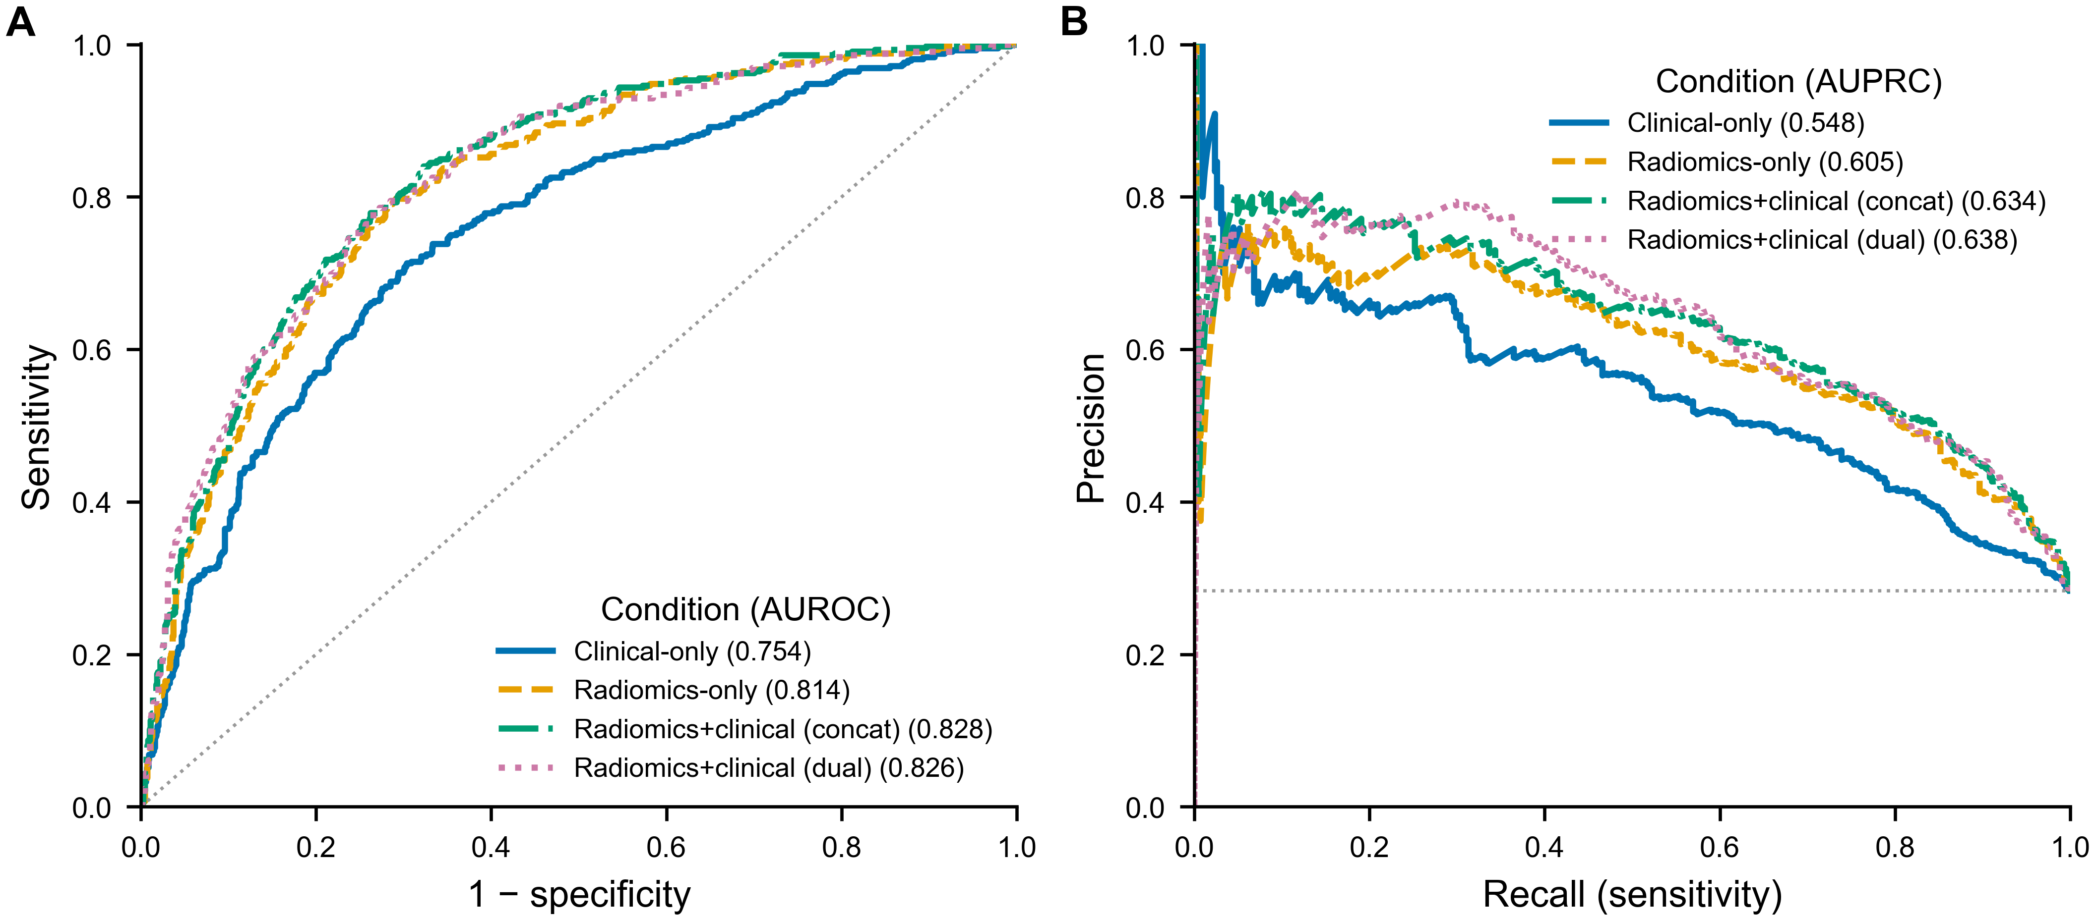
Discrimination of the best model in each condition on aligned out-of-fold predictions. (A) Receiver operating characteristic curves with pooled AUROC. (B) Precision–recall curves with pooled AUPRC; the dotted line marks the csPCa prevalence (0.283). Combining radiomics with clinical variables shifts both curves upward relative to radiomics alone, while clinical variables alone are clearly inferior.
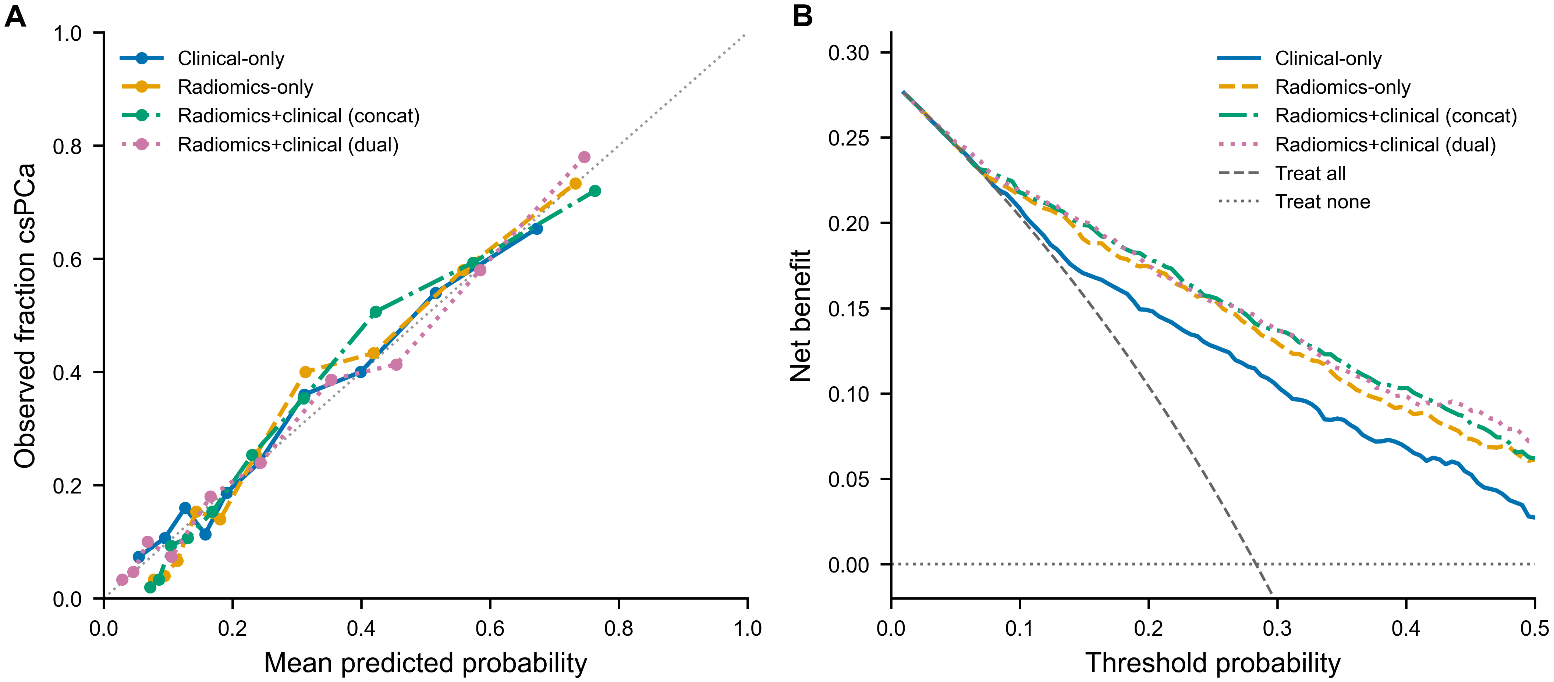
Calibration and clinical utility of the best model in each condition. (A) Reliability curves (10 quantile bins); the diagonal denotes perfect calibration. (B) Decision-curve analysis showing net benefit versus threshold probability, with treat-all and treat-none reference strategies.
Exploratory pairwise model comparisons (A versus B) on aligned out-of-fold predictions. $Δ$ is A$-$B; 95% CIs and raw bootstrap $P$ values are from a patient-level cluster bootstrap. Holm adjustment was applied across the six contrasts separately for AUROC and AUPRC. DeLong $P$ is the paired AUROC reference test. Confidence intervals are unadjusted and conditional on the screened model set.
Contrast (A vs. B) | $Δ$AUROC [95% CI] | Bootstrap $P$ raw (Holm) | DeLong $P$ raw (Holm) | $Δ$AUPRC [95% CI], $P$ raw (Holm)
Concat (RF) vs. radiomics-only (RF) | $+0.014$ [0.007, 0.021] | $<0.001$ ($<0.001$) | $<0.001$ ($<0.001$) | $+0.029$ [0.010, 0.050], 0.004 (0.022)
Dual (Transformer) vs. radiomics-only (RF) | $+0.012$ [$-0.004$, 0.027] | 0.133 (0.266) | 0.131 (0.261) | $+0.033$ [$-0.006$, 0.072], 0.092 (0.277)
Dual (Transformer) vs. concat (RF) | $-0.002$ [$-0.015$, 0.011] | 0.736 (0.736) | 0.727 (0.727) | $+0.004$ [$-0.026$, 0.034], 0.748 (1.000)
Radiomics-only RF vs. Transformer | $+0.014$ [$-0.001$, 0.029] | 0.068 (0.204) | 0.071 (0.213) | $-0.004$ [$-0.037$, 0.030], 0.829 (1.000)
Radiomics-only (RF) vs. clinical-only (Transformer–CapsNet) | $+0.060$ [0.029, 0.091] | $<0.001$ ($<0.001$) | $<0.001$ ($<0.001$) | $+0.057$ [0.002, 0.114], 0.042 (0.170)
Dual (Transformer) vs. clinical-only (Transformer–CapsNet) | $+0.072$ [0.049, 0.094] | $<0.001$ ($<0.001$) | $<0.001$ ($<0.001$) | $+0.090$ [0.052, 0.130], $<0.001$ ($<0.001$)

Performance across acquisition centers
Stratifying the pooled out-of-fold predictions by contributing center revealed substantial between-center heterogeneity (Table 5). For the radiomics-only Random Forest, discrimination was high and similar at RUMC (AUROC 0.835, 95% CI 0.804–0.863) and ZGT (0.834, 0.784–0.882) but markedly lower at PCNN (0.735, 0.678–0.788). The same pattern held for the combined models and was statistically significant: PCNN underperformed the other two centers by $0.102$ AUROC for the radiomics-only Random Forest (95% CI 0.041–0.163, $P=0.001$), by $0.130$ for the concatenation Random Forest ($P<0.001$), and by $0.153$ for the dual-branch Transformer ($P<0.001$). Notably, the incremental value of clinical variables was also center-dependent: adding clinical variables improved discrimination at RUMC and ZGT but not at PCNN, where the combined models were no better than—and for dual-branch fusion slightly worse than—the radiomics-only model. Because the cross-validation folds are not center-disjoint, these estimates reflect per-center performance of a center-mixed–trained model and not transportability to a wholly unseen center; the lower performance at PCNN nonetheless signals that acquisition-site characteristics materially affect this radiomic signature and that center-stratified evaluation is essential before deployment.
Discrimination by contributing center on pooled out-of-fold predictions for the best model in the radiomics-only, concatenation, and dual-branch conditions. Values are point estimates with patient-level cluster-bootstrap 95% confidence intervals. RUMC, Radboud University Medical Center; PCNN, Prostaat Centrum Noord-Nederland; ZGT, Ziekenhuisgroep Twente.
Model | Center | $n$ (csPCa %) | AUROC | AUPRC
Radiomics-only (Random Forest) | All | 1500 (28.3) | 0.814 (0.791–0.837) | 0.605 (0.554–0.659)
 | RUMC | 800 (29.5) | 0.835 (0.804–0.863) | 0.672 (0.606–0.733)
 | ZGT | 350 (22.9) | 0.834 (0.784–0.882) | 0.581 (0.469–0.700)
 | PCNN | 350 (31.1) | 0.735 (0.678–0.788) | 0.520 (0.429–0.624)
Radiomics$+$clinical concat (Random Forest) | All | 1500 (28.3) | 0.828 (0.806–0.850) | 0.634 (0.583–0.687)
 | RUMC | 800 (29.5) | 0.850 (0.821–0.877) | 0.706 (0.642–0.765)
 | ZGT | 350 (22.9) | 0.863 (0.816–0.906) | 0.642 (0.528–0.751)
 | PCNN | 350 (31.1) | 0.725 (0.667–0.780) | 0.511 (0.422–0.614)
Radiomics$+$clinical dual (Transformer) | All | 1500 (28.3) | 0.826 (0.803–0.848) | 0.638 (0.589–0.691)
 | RUMC | 800 (29.5) | 0.860 (0.830–0.886) | 0.740 (0.679–0.794)
 | ZGT | 350 (22.9) | 0.855 (0.807–0.899) | 0.635 (0.520–0.749)
 | PCNN | 350 (31.1) | 0.706 (0.648–0.761) | 0.493 (0.405–0.598)

Interpretability
In-fold feature selection was compact and highly reproducible. A mean of 67.6 features was retained per fold (SD 0.9; range 67–69), drawn from 99 distinct features across the five folds; 41 of these were selected in every fold and 60 in at least four, with a mean pairwise Jaccard overlap of 0.68 (Figure 5A), indicating a stable radiomic signature rather than fold-dependent selection. The signature was strongly diffusion-weighted: of the 99 features, 80 were derived from DWI, 12 from T2w, and 7 from ADC (Figure 5B). Although fewer in number, ADC descriptors were a consistent component (three to six were retained in every fold) and were not incidental to prediction, recurring among the most important variables of all six models.
Feature-attribution analyses for the best model of each condition characterized both the magnitude and the direction of the leading predictors (Figure 4). In the radiomics-only Random Forest, the dominant features were diffusion-weighted texture and first-order descriptors: DWI gray-level co-occurrence informational measure of correlation (Imc1) and correlation, neighbouring-gray-tone-difference strength, and the skewness and kurtosis of the high b-value signal. The clinical-only model distributed its importance across all four variables in clinically expected directions: higher prostate-specific antigen, higher PSA density, and older age increased the predicted probability of csPCa, whereas larger prostate volume decreased it. Crucially, when the two information sources were combined the clinical variables rose to the top of the ranking: PSA density was the single most important feature in the concatenation Random Forest (ahead of every radiomic descriptor, with higher values increasing csPCa probability) and all four clinical variables—age, PSA density, prostate-specific antigen, and prostate volume—appeared among the leading features of the dual-branch Transformer, interleaved with diffusion- and T2-weighted texture, including DWI gray-level co-occurrence (Imc1), DWI first-order skewness, and T2-weighted gray-level non-uniformity and coarseness. This re-ranking offers a direct explanation for the modest discrimination gain conferred by the clinical variables: rather than refining the radiomic signal, they contributed largely independent, high-value information dominated by PSA density.
Effect directions were concordant between the SHAP (classical) and integrated-gradient (deep) analyses for the features they shared. Among the radiomics-only models, agreement on the ranking of individual features across all six architectures was nonetheless only moderate (mean pairwise top-15 Jaccard 0.27; Random Forest and the Transformer shared 5 of their 15 leading features; Figure 6), reflecting the redundancy of the high-dimensional radiomic space; despite this, one diffusion-weighted gray-level co-occurrence feature (wavelet-filtered correlation) ranked among the fifteen most important features of every model, a signature shared across classical and deep architectures. Finally, a selected set of influential features was back-projected to the image as voxel-level maps in csPCa-positive cases with human-expert lesion delineations (Figure 7). The displayed set retained the ADC square-root first-order total-energy map and the recurrent DWI Imc texture features, and added a DWI LoG first-order skewness map and a DWI square GLRLM gray-level non-uniformity map to capture complementary diffusion-weighted first-order and run-length texture patterns. Their salient regions co-localized with the delineated csPCa lesion rather than being distributed uniformly through the gland; the ADC total-energy map and the diffusion-weighted texture maps repeatedly highlighted the same focus. These feature-resolved maps provide case-level spatial explanations directly on the anatomy, complementing the global importance summaries.
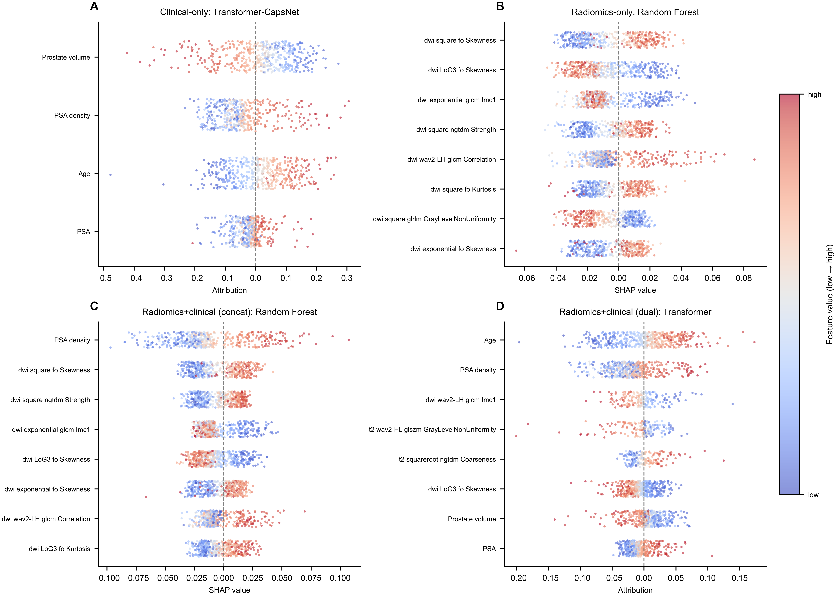
Direction and magnitude of feature effects for the best model in each condition. Beeswarm summaries for (A) the clinical-only Transformer–CapsNet and (D) the dual-branch Transformer (integrated-gradient attributions), and (B) the radiomics-only and (C) the concatenation Random Forest (SHAP values), for the eight most important features of each model (pooled out-of-fold studies). Each point is a study, positioned by its signed attribution and coloured by the relative feature value (low to high); attributions to the right of zero increase the predicted csPCa probability. In the combined models (C, D) the clinical variables—PSA density in particular—rank among the most influential features.
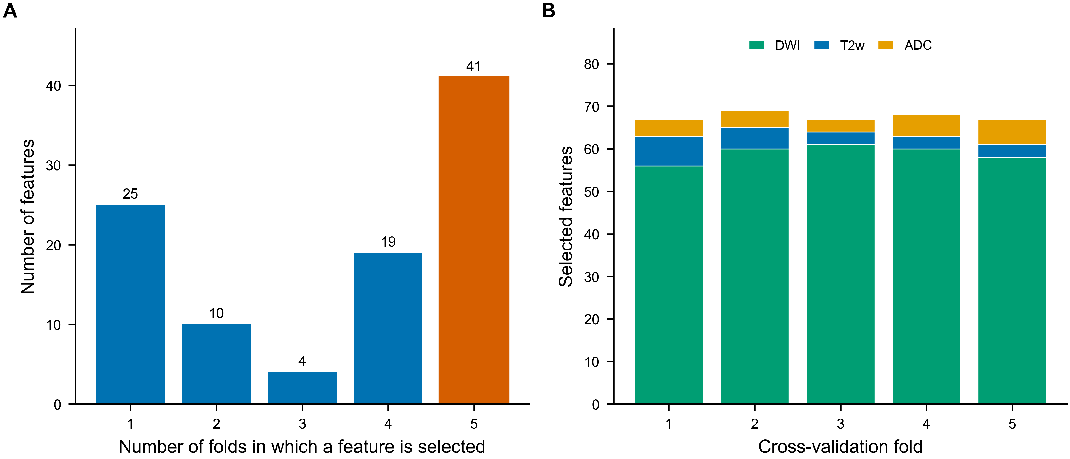
Stability of in-fold feature selection. (A) Number of features selected in exactly $k$ of the five folds; 41 features (orange) were selected in all folds. (B) Per-fold composition of the selected set by source sequence. Selection is reproducible across folds and dominated by diffusion-weighted imaging.
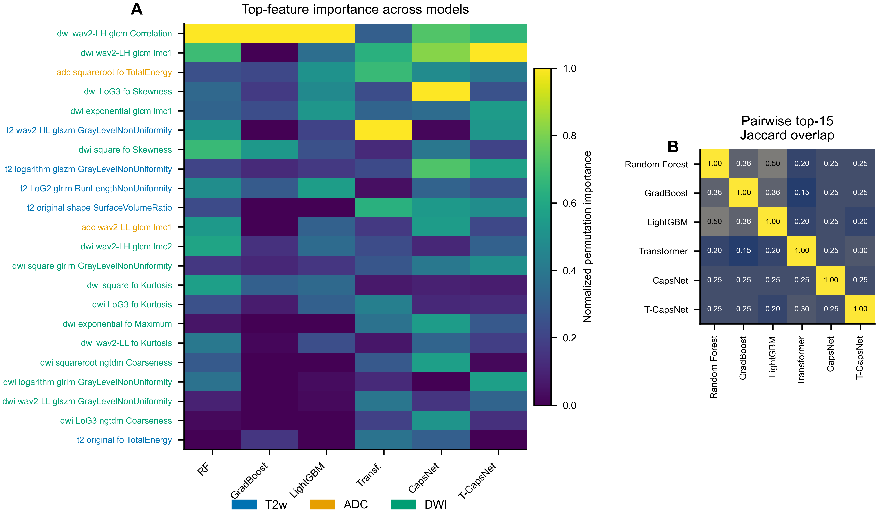
Cross-model feature-importance concordance. (A) Normalized permutation importance of the most informative features (union of each model’s top ten) across all six models; row labels are colored by source sequence. (B) Pairwise overlap (top-15 Jaccard) of the most important features between models. One diffusion-weighted GLCM feature appears in every model’s top fifteen, while overall feature-level agreement is moderate.
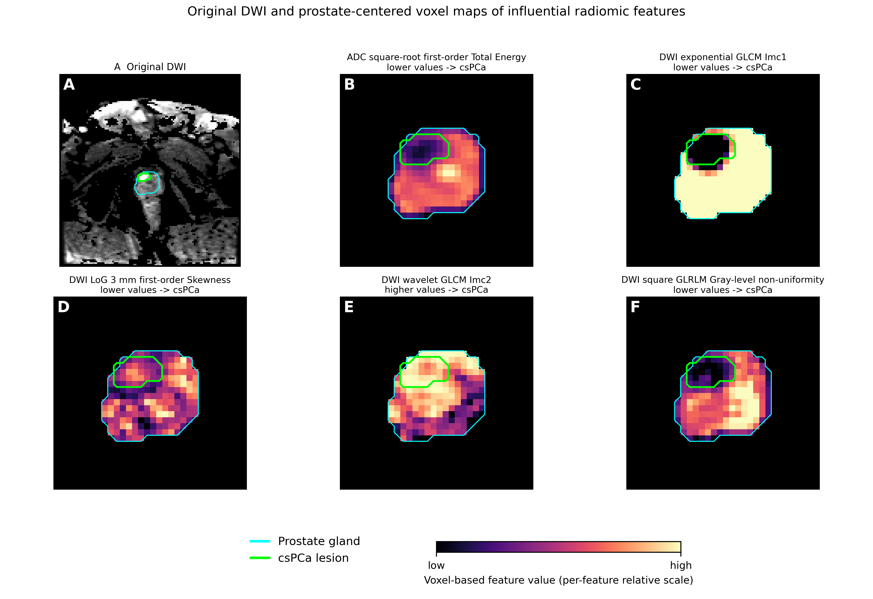  Case 10322_1000328. | 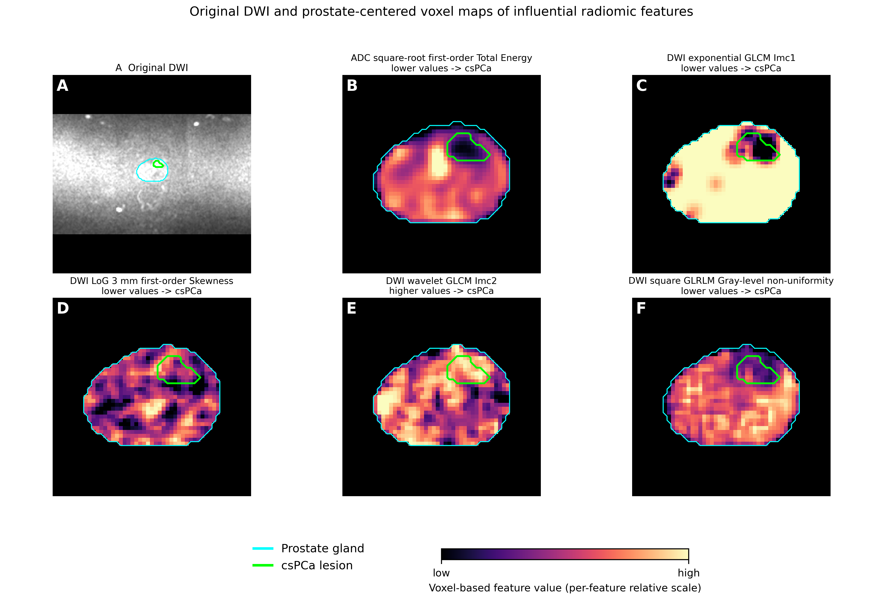  Case 11377_1001400. | 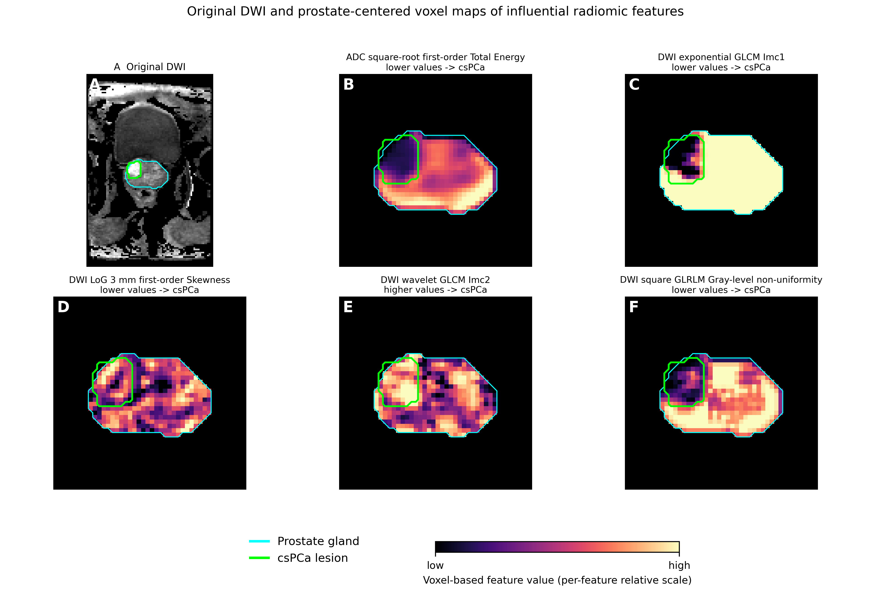  Case 10383_1000389.
Original DWI and prostate-centered voxel-based radiomic maps in csPCa-positive cases with human-expert lesion delineations. In each subfigure, (A) original DWI slice with prostate gland (cyan) and csPCa lesion (green) delineations only; (B) ADC square-root first-order total energy, (C) DWI exponential GLCM Imc1, (D) DWI LoG 3 mm first-order skewness, (E) DWI wavelet GLCM Imc2, and (F) DWI square GLRLM gray-level non-uniformity. Feature panels show only the voxel map within a prostate-centered bounding box, with the gland and lesion contours retained. Colour encodes voxel-based feature value on a per-feature relative scale (low to high). Panel titles indicate the feature direction from the signed SHAP/integrated-gradient beeswarm analyses: lower values support the positive csPCa class for B–D and F, whereas higher values support the positive csPCa class for E.

Discussion
This study benchmarked classical machine learning against deep tabular learning on an identical biparametric-MRI radiomic feature space for csPCa detection and quantified the value added by routine clinical variables. Two findings stand out. First, a classical Random Forest matched or exceeded all evaluated deep tabular pipelines on radiomics-only data, although its specified comparison with the Transformer was not significant after multiplicity adjustment. The numerical ranking is consistent with the broader evidence that tree ensembles remain strong baselines for moderate-sized tabular problems with engineered features. Notably, the deep models were selected precisely for their stronger inductive biases (explicit feature-interaction modeling via attention, and part–whole representation via capsule routing)—yet these did not translate into higher discrimination under the implemented training protocol. Second, adding age, PSA, PSA density, and prostate volume to radiomics by simple concatenation produced a small improvement in AUROC and AUPRC that remained significant after Holm adjustment, whereas dual-branch fusion gave no demonstrated benefit over simple feature concatenation. The interpretability analysis added a third dimension to these benchmark results: the selected radiomic signature was compact and highly reproducible across folds, was dominated by diffusion-weighted texture with a smaller but consistent ADC contribution, and converged (most clearly on a wavelet-filtered diffusion-weighted GLCM correlation feature that ranked among the fifteen most important variables of every model, together with complementary first-order and texture descriptors) across otherwise dissimilar classical and deep architectures. In the combined models the picture changed informatively: the clinical variables, and PSA density in particular, rose to the very top of the importance ranking, indicating that their benefit came from largely independent risk information rather than from refining the imaging signal. Mapping the selected high-importance features back onto the anatomy showed that their salient regions coincided with the delineated lesion (most strikingly for the ADC square-root total-energy map and recurrent DWI texture maps) rather than being spread uniformly through the gland, reinforcing the biological plausibility of the models and illustrating the feature-resolved spatial explanations this radiomics workflow can provide.
The identity and direction of the most influential features are biologically coherent with the pathophysiology of csPCa. Clinically significant tumours are densely cellular, which restricts water diffusion and produces the low ADC and elevated high b-value signal that underpin the diffusion sequences; accordingly, the models relied heavily on diffusion-weighted descriptors, and the quantitative ADC features surfaced by the deep models (including ADC first-order total energy) are consistent with reduced diffusion within hypercellular tumour. The texture descriptors that recurred across models, including gray-level co-occurrence correlation and informational measures of correlation, quantify the spatial orderliness and predictability of voxel intensities: malignant tissue disrupts the regular glandular architecture of the prostate, lowering this organized correlation structure and raising heterogeneity, which is also reflected in the gray-level non-uniformity and NGTDM strength descriptors and in the skewness and kurtosis of the high b-value signal, sensitive to focal restricted-diffusion foci against benign background. The single T2w gland-shape feature (surface-to-volume ratio) likely captures coarse morphological correlates of disease burden. The overarching tendency was therefore that greater textural heterogeneity and more restricted diffusion shifted predictions toward csPCa. The clinical variables that dominated the combined models follow established urological risk relationships: higher PSA and PSA density, older age, and smaller prostate volume are all recognized markers of csPCa risk, and PSA density—PSA normalized to gland volume—is a particularly strong discriminator because it jointly encodes the higher PSA and the smaller glands typical of significant cancer, which explains why it outranked the individual radiomic descriptors once available to the model. That these data-driven directions reproduce known clinical relationships strengthens confidence that the combined model captured genuine, complementary risk signal rather than dataset-specific artefact. These attributions should nonetheless be read as associations rather than mechanisms, and because individual descriptors are computed after intensity-transforming filters (square, Laplacian-of-Gaussian, wavelet) the sign of any single filtered variant depends partly on the transform; the robust, model-agnostic signal is the recurrent diffusion correlation/Imc texture rather than any one coefficient, and whole-gland extraction means the features summarize the entire gland rather than a delineated lesion.
A calibrated csPCa risk model warrants evaluation for biopsy decision-making, triage, and second-reader workflows. At the outer-training-derived operating point the models achieved a balanced sensitivity and specificity of roughly 0.75, with a high negative predictive value (about 0.89) that is well suited to ruling out csPCa and avoiding unnecessary biopsies; because the probabilities are calibrated, the threshold can be shifted toward higher sensitivity where avoiding missed csPCa is the priority, as the decision-curve analysis supports across the plausible range. The moderate positive predictive value (about 0.53) reflects the disease prevalence and indicates that a positive prediction warrants confirmatory work-up rather than standalone decision-making. Because the incremental value of clinical variables is small but real and the variables are already collected in routine practice, a combined model is a low-cost route to improved discrimination.
The radiomics-only performance obtained here is competitive with recently published literature, where well-tuned classical models frequently establish a high bar for csPCa detection . However, direct performance comparisons are often confounded by evaluation design. Many earlier radiomics studies relied on smaller single-center cohorts or lesion-level cross-validation without patient grouping, introducing optimistic bias and severely overestimating performance . By adhering to TRIPOD+AI guidelines with strictly leakage-safe, patient-grouped cross-validation on the large PI-CAI cohort , the present study provides a conservative internal-validation benchmark. Under the implemented protocol, the deep tabular pipelines did not surpass the classical ensemble, a pattern also reported in some external evaluations. For example, Castillo et al. demonstrated that while fully automated DL achieved higher internal cross-validation performance, classical radiomics generalized better across independent external cohorts . The engineered inputs may already encode much of the relevant diffusion and texture information, but the present pipeline-level comparison cannot determine whether the remaining difference arises from model architecture or other differences in optimization and regularization. To bound the latter possibility, we re-ran the deep models under an optimistically biased protocol that selected the training epoch on the held-out fold itself (Supplementary Material, Table S1); even with this advantage the deep models failed to surpass the classical Random Forest in the radiomics-only setting and gained only a small, leakage-inflated margin in the combined conditions, indicating that the classical baseline is not an artefact of an unfavorable deep-model training schedule.
Likewise, the predictive value added by clinical variables mirrors prior multicenter findings. Consistent with existing risk models, PSA density emerged as the strongest routine clinical complement to MRI . While studies such as Antolín et al. reported larger discrimination gains from multimodal integration, those hybrid models incorporated PI-RADS scores and extended clinical predictors . By deliberately omitting PI-RADS to isolate the whole-gland radiomic signal, our results demonstrate that a parsimonious set of routine variables still adds incremental predictive information. The lack of benefit from dual-branch fusion over simple concatenation further emphasizes that a more complex architecture does not necessarily add value when combining data streams that carry largely distinct risk profiles.
The study has limitations. It was a retrospective analysis without external validation; all estimates are multicenter internal cross-validation on a single cohort, so generalization to other scanners, protocols, and populations is unverified. The patient-grouped folds were not center-disjoint, so acquisition-specific signatures could be shared between training and held-out folds; consequently, although discrimination is reported per center (Section 3.3), true cross-center transportability—which would require leave-one-center-out retraining or an external cohort—was not tested. The center-stratified analysis is itself an important caution: discrimination was substantially and significantly lower at one of the three centers (PCNN), and the incremental value of clinical variables was not uniform across sites, indicating that aggregate performance can mask clinically relevant site-level heterogeneity. PI-RADS scores could not be recovered from the public metadata, so the radiomic and combined models could not be benchmarked against, or combined with, the standard radiological assessment. Features were extracted from whole-gland rather than lesion-level masks, and the masks were automatically generated, introducing potential segmentation variability. PSA density was missing for nearly one third of studies and was imputed, which may attenuate its contribution. The cohort is class-imbalanced, and the absolute gains from clinical variables, while statistically significant, are modest. In addition, the preliminary screening of twelve classical algorithms and the selection of condition winners reused the evaluation cohort. The pairwise comparisons are therefore exploratory, and their bootstrap intervals do not capture model-selection uncertainty. Nested algorithm selection or independent validation is needed for confirmatory inference. Future work should include external and prospective validation, lesion-level and zonal feature extraction, richer clinical variables, and prospective evaluation within a clinical decision pathway .

Conclusion
In this large, multicenter PI-CAI cohort, whole-gland radiomic features derived from biparametric MRI provided meaningful discrimination of clinically significant prostate cancer under multicenter internal validation. Under the implemented training protocol, a calibrated Random Forest achieved the strongest radiomics-only performance and was numerically above the deep tabular pipelines, but the specified Random Forest–Transformer difference was not significant after multiplicity adjustment. This result does not establish an architectural advantage for classical models. Classical tree ensembles therefore remain essential reference models for radiomics studies and may offer a more parsimonious choice when sample size is moderate and the feature space is structured and tabular.
Routine clinical variables supplied complementary information. Adding age, PSA, PSA density, and prostate volume to the radiomic signature produced a modest but statistically supported improvement, particularly in AUPRC, while a dual-branch fusion architecture did not outperform straightforward feature concatenation. Together with the interpretability analyses, these results indicate that diffusion-weighted texture and ADC-derived descriptors capture a reproducible imaging phenotype, whereas PSA density and the other clinical variables contribute additional risk information that is not fully represented by imaging. The resulting calibrated radiomics–clinical model may be useful as a quantitative adjunct for biopsy triage or MRI second reading, especially when high negative predictive value is prioritized; however, it should support, rather than replace, radiological and clinical assessment.
Clinical translation will require evaluation beyond internal cross-validation. Independent external and prospective validation should establish robustness across institutions, scanners, acquisition protocols, segmentation methods, and patient populations, and should assess performance at clinically prespecified decision thresholds. Future studies should also determine whether lesion-level or zonal radiomics, additional clinical predictors, or longitudinal information provide gains that justify their added complexity. Until such validation is available, the present work should be interpreted as a rigorous comparative benchmark and as evidence that a relatively simple, calibrated, and interpretable multimodal model can provide competitive csPCa risk estimation from routinely available biparametric MRI and clinical data.

Data Availability
The anonymized PI-CAI Public Training and Development Dataset is available through the PI-CAI challenge under the applicable data-use terms and a CC BY-NC 4.0 license . The imaging data are archived at Zenodo (https://doi.org/10.5281/zenodo.6624726), and the maintained annotations are available from https://github.com/DIAGNijmegen/picai_labels. The clinical manifest and modality-specific extracted radiomic feature tables used to construct the analysis dataset are included in the accompanying code repository. Intermediate combined tables, trained model files, and generated reports can be reproduced from these resources using the provided configurations and workflow scripts.

Code Availability
The complete analysis workflow, including radiomic feature processing, model training, statistical evaluation, interpretability analysis, and figure generation, is publicly available at https://github.com/jesusalzate/Radiomics-Prostate-Cancer.

Ethics Approval
This study was a secondary analysis of fully anonymized data released for the PI-CAI challenge and involved no new participant recruitment, intervention, or access to directly identifiable information. For the source PI-CAI cohort, the institutional review boards of Radboud University Medical Center, Ziekenhuis Groep Twente, University Medical Center Groningen, and the Norwegian University of Science and Technology waived the requirement for informed consent for the retrospective scientific use of anonymized clinical data .

Author Contributions
Conceptualization: J.A.A.-G., R.T.-S., J.M.G.-G., M.I.-V. Methodology: J.A.A.-G., M.A.B.-O., F.G.-G. Software: J.A.A.-G., M.A.B.-O., L.M.C.P., S.L.M. Validation: J.A.A.-G., M.P.-T., A.N.B., C.R.T. Formal analysis: J.A.A.-G., F.G.-G. Investigation: J.A.A.-G., M.A.B.-O., L.M.C.P., S.L.M. Resources (clinical and imaging data): M.P.-T., A.N.B., C.R.T., J.M.O.G., M.I.-V. Data curation: J.A.A.-G., M.P.-T., J.M.O.G. Writing – original draft: J.A.A.-G. Writing – review & editing: all authors. Visualization: J.A.A.-G., M.A.B.-O. Supervision: R.T.-S., J.M.G.-G., M.I.-V. Funding acquisition: J.A.A.-G., M.I.-V. All authors read and approved the final manuscript.

Funding
This work was partially supported by the Asociación Española Contra el Cáncer (AECC) through the Ayuda Predoctoral AECC Valencia 2025, grant ID PRDVA258654ALZA. The funder had no role in study design, data collection, data analysis, data interpretation, manuscript preparation, or the decision to submit the article for publication.

Conflicts of Interest
The authors declare no conflicts of interest.

References
Federico Midiri, Federica Vernuccio, Pierpaolo Purpura, Pierpaolo Alongi, and Tommaso Vincenzo Bartolotta. Multiparametric MRI and radiomics in prostate cancer: A review of the current literature. Diagnostics, 11 (10): 1829, 2021. doi: 10.3390/diagnostics11101829.
Huanye Li, Chau Hung Lee, David Chia, Zhiping Lin, Weimin Huang, and Cher Heng Tan. Machine learning in prostate MRI for prostate cancer: Current status and future opportunities. Diagnostics, 12 (2): 289, 2022. doi: 10.3390/diagnostics12020289.
Jie Bao, Xiaomeng Qiao, Yang Song, Yueting Su, Libiao Ji, Junkang Shen, Guang Yang, Hailin Shen, Ximing Wang, and Chunhong Hu. Prediction of clinically significant prostate cancer using radiomics models in real-world clinical practice: A retrospective multicenter study. Insights into Imaging, 15 (1): 68, 2024. doi: 10.1186/s13244-024-01631-w.
Xuehua Zhu, Lizhi Shao, Zhenyu Liu, Zenan Liu, Jide He, Jiangang Liu, Hao Ping, and Jian Lu. -derived radiomics models for diagnosis, aggressiveness, and prognosis evaluation in prostate cancer. Journal of Zhejiang University-Science B, 24 (8): 663–681, 2023. doi: 10.1631/jzus.B2200619.
Gary S. Collins, Karel G. M. Moons, Paula Dhiman, Richard D. Riley, Andrew L. Beam, Ben Van Calster, Marzyeh Ghassemi, Xiaoxuan Liu, Johannes B. Reitsma, Maarten van Smeden, Anne-Laure Boulesteix, Jennifer C. Camaradou, Leo Anthony Celi, Spiros Denaxas, Alastair K. Denniston, Ben Glocker, Robert M. Golub, Hugh Harvey, Georg Heinze, Michael M. Hoffman, Andre Pascal Kengne, Emily Lam, Naomi Lee, Elizabeth W. Loder, Lena Maier-Hein, Bilal A. Mateen, Melissa D. McCradden, Lauren Oakden-Rayner, Johan Ordish, Richard Parnell, Sherri Rose, Karandeep Singh, Laure Wynants, and Patricia Logullo. statement: updated guidance for reporting clinical prediction models that use regression or machine learning methods. BMJ, 385: e078378, 2024. doi: 10.1136/bmj-2023-078378.
Eva Gresser, Balthasar Schachtner, Anna Theresa Stüber, Olga Solyanik, Andrea Schreier, Thomas Huber, Matthias Frank Froelich, Giuseppe Magistro, Alexander Kretschmer, Christian Stief, Jens Ricke, Michael Ingrisch, and Dominik Nörenberg. Performance variability of radiomics machine learning models for the detection of clinically significant prostate cancer in heterogeneous MRI datasets. Quantitative Imaging in Medicine and Surgery, 12 (11): 4990–5003, 2022. doi: 10.21037/qims-22-265.
Henrik J. Michaely, Giacomo Aringhieri, Dania Cioni, and Emanuele Neri. Current value of biparametric prostate MRI with machine-learning or deep-learning in the detection, grading, and characterization of prostate cancer: A systematic review. Diagnostics, 12 (4): 799, 2022. doi: 10.3390/diagnostics12040799.
Jose M. Castillo T., Muhammad Arif, Martijn P. A. Starmans, Wiro J. Niessen, Chris H. Bangma, Ivo G. Schoots, and Jifke F. Veenland. Classification of clinically significant prostate cancer on multi-parametric MRI: A validation study comparing deep learning and radiomics. Cancers, 14 (1): 12, 2021. doi: 10.3390/cancers14010012.
Jose M. Castillo T., Muhammad Arif, Wiro J. Niessen, Ivo G. Schoots, and Jifke F. Veenland. Automated classification of significant prostate cancer on MRI: A systematic review on the performance of machine learning applications. Cancers, 12 (6): 1606, 2020. doi: 10.3390/cancers12061606.
Andreu Antolin, Richard Mast, Nuria Roson, Javier Arce, Ramon Almodovar, Roger Cortada, Anna Alberti, Berta Miro, Olga Mendez, Almudena Maceda, Esther Serrano, Carmen Prieto-de-la Lastra, Ana Jimenez-Pastor, Anna Nogué-Infante, Manuel Escobar, Enrique Trilla, and Juan Morote. Combined radiomics, PI-RADS, and clinical model improve significant prostate cancer prediction and guide biopsy decision. Insights into Imaging, 17 (1): 118, 2026. doi: 10.1186/s13244-026-02295-4.
Feng Lu, Yanjun Zhao, Zhongjuan Wang, and Ninghan Feng. Biparametric MRI-based radiomics for prediction of clinically significant prostate cancer of PI-RADS category 3 lesions. BMC Cancer, 25 (1): 615, 2025. doi: 10.1186/s12885-025-14022-1.
Jinhan Yang, Ningning Jiang, Yongsheng Zhang, Liqin Yang, Lu Xia, Yue Ren, Huijing Xu, Zhiping Li, Junguang Wang, and Feng Cui. Developing an interpretable clinical-radiomics machine learning model using whole transition zone MRI analysis for improving diagnosis of transition zone prostate cancer. Frontiers in Oncology, 16: 1716482, 2026. doi: 10.3389/fonc.2026.1716482.
Philippe Lambin, Ralph T. H. Leijenaar, Timo M. Deist, Jurgen Peerlings, Evelyn E. C. de Jong, Janita van Timmeren, Sebastian Sanduleanu, Ruben T. H. M. Larue, Aniek J. G. Even, Arthur Jochems, et al. Radiomics: the bridge between medical imaging and personalized medicine. Nature Reviews Clinical Oncology, 14 (12): 749–762, 2017. doi: 10.1038/nrclinonc.2017.141.
Anindo Saha, Joeran S. Bosma, Jasper J. Twilt, Bram van Ginneken, Anders Bjartell, Anwar R. Padhani, David Bonekamp, Geert Villeirs, Georg Salomon, Gianluca Giannarini, Jayashree Kalpathy-Cramer, Jelle Barentsz, Klaus H. Maier-Hein, Mirabela Rusu, Olivier Rouvière, Roderick van den Bergh, Valeria Panebianco, Veeru Kasivisvanathan, Nancy A. Obuchowski, Derya Yakar, Mattijs Elschot, Jeroen Veltman, Jurgen J. Fütterer, Maarten de Rooij, Henkjan Huisman, and PI-CAI Consortium. Artificial intelligence and radiologists in prostate cancer detection on MRI (PI-CAI): An international, paired, non-inferiority, confirmatory study. The Lancet Oncology, 25 (7): 879–887, 2024. doi: 10.1016/S1470-2045(24)00220-1.
Jonathan I. Epstein, Lars Egevad, Mahul B. Amin, Brett Delahunt, John R. Srigley, Peter A. Humphrey, and Grading Committee. The 2014 international society of urological pathology (ISUP) consensus conference on Gleason grading of prostatic carcinoma: definition of grading patterns and proposal for a new grading system. The American Journal of Surgical Pathology, 40 (2): 244–252, 2016. doi: 10.1097/PAS.0000000000000530.
Baris Turkbey, Andrew B. Rosenkrantz, Masoom A. Haider, Anwar R. Padhani, Geert Villeirs, Katarzyna J. Macura, Clare M. Tempany, Peter L. Choyke, Francois Cornud, et al. Prostate imaging reporting and data system version 2.1: 2019 update of prostate imaging reporting and data system version 2. European Urology, 76 (3): 340–351, 2019. doi: 10.1016/j.eururo.2019.02.033.
Joost J. M. van Griethuysen, Andriy Fedorov, Chintan Parmar, Ahmed Hosny, Nicole Aucoin, Vivek Narayan, Regina G. H. Beets-Tan, Jean-Christophe Fillion-Robin, Steve Pieper, and Hugo J. W. L. Aerts. Computational radiomics system to decode the radiographic phenotype. Cancer Research, 77 (21): e104–e107, 2017. doi: 10.1158/0008-5472.CAN-17-0339.
Alex Zwanenburg, Martin Vallières, Mahmoud A. Abdalah, Hugo J. W. L. Aerts, Vincent Andrearczyk, Aditya Apte, Saeed Ashrafinia, Spyridon Bakas, Roelof J. Beukinga, Ronald Boellaard, et al. The image biomarker standardization initiative: standardized quantitative radiomics for high-throughput image-based phenotyping. Radiology, 295 (2): 328–338, 2020. doi: 10.1148/radiol.2020191145.
Henry B. Mann and Donald R. Whitney. On a test of whether one of two random variables is stochastically larger than the other. The Annals of Mathematical Statistics, 18 (1): 50–60, 1947. doi: 10.1214/aoms/1177730491.
Yoav Benjamini and Yosef Hochberg. Controlling the false discovery rate: a practical and powerful approach to multiple testing. Journal of the Royal Statistical Society: Series B (Methodological), 57 (1): 289–300, 1995. doi: 10.1111/j.2517-6161.1995.tb02031.x.
Leo Breiman. Random forests. Machine Learning, 45 (1): 5–32, 2001. doi: 10.1023/A:1010933404324.
Jerome H. Friedman. Greedy function approximation: a gradient boosting machine. Annals of Statistics, 29 (5): 1189–1232, 2001. doi: 10.1214/aos/1013203451.
Guolin Ke, Qi Meng, Thomas Finley, Taifeng Wang, Wei Chen, Weidong Ma, Qiwei Ye, and Tie-Yan Liu. : a highly efficient gradient boosting decision tree. In Advances in Neural Information Processing Systems, volume 30, 2017.
John C. Platt. Probabilistic outputs for support vector machines and comparisons to regularized likelihood methods. In A. J. Smola, P. J. Bartlett, B. Schölkopf, and D. Schuurmans, editors, Advances in Large Margin Classifiers, pages 61–74. MIT Press, 1999.
Yury Gorishniy, Ivan Rubachev, Valentin Khrulkov, and Artem Babenko. Revisiting deep learning models for tabular data. In Advances in Neural Information Processing Systems, volume 34, pages 18932–18943, 2021.
Ashish Vaswani, Noam Shazeer, Niki Parmar, Jakob Uszkoreit, Llion Jones, Aidan N. Gomez, Łukasz Kaiser, and Illia Polosukhin. Attention is all you need. In Advances in Neural Information Processing Systems, volume 30, 2017.
Sara Sabour, Nicholas Frosst, and Geoffrey E. Hinton. Dynamic routing between capsules. In Advances in Neural Information Processing Systems, volume 30, 2017.
Dan Hendrycks and Kevin Gimpel. Gaussian error linear units (GELUs). arXiv preprint arXiv:1606.08415, 2016.
Sergey Ioffe and Christian Szegedy. Batch normalization: accelerating deep network training by reducing internal covariate shift. In Proceedings of the 32nd International Conference on Machine Learning (ICML), pages 448–456, 2015.
Tsung-Yi Lin, Priya Goyal, Ross Girshick, Kaiming He, and Piotr Dollár. Focal loss for dense object detection. In Proceedings of the IEEE International Conference on Computer Vision (ICCV), pages 2980–2988, 2017. doi: 10.1109/ICCV.2017.324.
Diederik P. Kingma and Jimmy Ba. Adam: a method for stochastic optimization. In International Conference on Learning Representations (ICLR), 2015.
Ilya Loshchilov and Frank Hutter. : stochastic gradient descent with warm restarts. In International Conference on Learning Representations (ICLR), 2017.
Glenn W. Brier. Verification of forecasts expressed in terms of probability. Monthly Weather Review, 78 (1): 1–3, 1950. doi: 10.1175/1520-0493(1950)078<0001:VOFEIT>2.0.CO;2.
William J. Youden. Index for rating diagnostic tests. Cancer, 3 (1): 32–35, 1950. doi: 10.1002/1097-0142(1950)3:1<32::aid-cncr2820030106>3.0.co;2-3.
Andrew J. Vickers and Elena B. Elkin. Decision curve analysis: a novel method for evaluating prediction models. Medical Decision Making, 26 (6): 565–574, 2006. doi: 10.1177/0272989X06295361.
Brian W. Matthews. Comparison of the predicted and observed secondary structure of T4 phage lysozyme. Biochimica et Biophysica Acta (BBA)—Protein Structure, 405 (2): 442–451, 1975. doi: 10.1016/0005-2795(75)90109-9.
Scott M. Lundberg and Su-In Lee. A unified approach to interpreting model predictions. In Advances in Neural Information Processing Systems, volume 30, 2017.
Mukund Sundararajan, Ankur Taly, and Qiqi Yan. Axiomatic attribution for deep networks. In Proceedings of the 34th International Conference on Machine Learning (ICML), pages 3319–3328, 2017.
Aaron Fisher, Cynthia Rudin, and Francesca Dominici. All models are wrong, but many are useful: learning a variable’s importance by studying an entire class of prediction models simultaneously. Journal of Machine Learning Research, 20 (177): 1–81, 2019.
Renato Cuocolo, Maria Brunella Cipullo, Arnaldo Stanzione, Valeria Romeo, Romain Green, Valeria Cantoni, Andrea Ponsiglione, Lorenzo Ugga, and Massimo Imbriaco. Machine learning for the identification of clinically significant prostate cancer on MRI: a systematic review. European Journal of Radiology, 133: 109031, 2021. doi: 10.1016/j.ejrad.2020.109031.
Andreu Antolin, Nuria Roson, Richard Mast, Javier Arce, Ramon Almodovar, Roger Cortada, Almudena Maceda, Manuel Escobar, Enrique Trilla, and Juan Morote. The role of radiomics in the prediction of clinically significant prostate cancer in the PI-RADS v2 and v2.1 era: A systematic review. Cancers, 16 (17): 2951, 2024. doi: 10.3390/cancers16172951.
Jeroen Bleker, Thomas C. Kwee, and Derya Yakar. Quality of multicenter studies using MRI radiomics for diagnosing clinically significant prostate cancer: A systematic review. Life, 12 (7): 946, 2022. doi: 10.3390/life12070946.
Wolfgang Krauss, Janusz Frey, Jakob Heydorn Lagerlöf, Mats Lidén, and Per Thunberg. Radiomics from multisite MRI and clinical data to predict clinically significant prostate cancer. Acta Radiologica, 65 (3): 307–317, 2024. doi: 10.1177/02841851231216555.
Guodong Jing, Pengyi Xing, Zhihui Li, Xiaolu Ma, Haidi Lu, Chengwei Shao, Yong Lu, Jianping Lu, and Fu Shen. Prediction of clinically significant prostate cancer with a multimodal MRI-based radiomics nomogram. Frontiers in Oncology, 12: 918830, 2022. doi: 10.3389/fonc.2022.918830.

